Project Documentation
Project Title:Streamlining IT Procurement: Automating Standard Laptop Orders with Flow Designer

Team Id: SWTID-2026-4947
Team Leader : Sanjana M - 202400138@sigc.edu
Team Member: Aiswariya S - 202400019@sigc.edu
Team Member: Harini K - 202400608@sigc.edu
Team Member: Renugadevi I - 202400943@sigc.edu

Problem Statement:
The current IT procurement process lacks efficiency and automation, resulting in delays and manual overhead, particularly in handling standard laptop orders. Requests for standard laptops often require configuration, but this step is prone to oversight or delay, leading to frustration among users and inefficient resource allocation within the IT department.

User Story:
As a member of the IT procurement team, I want a streamlined process for ordering standard laptops so that tasks are automatically generated and assigned to the hardware team for configuration. This will ensure that laptops are promptly configured upon arrival, reducing user wait times and minimising manual intervention.

Project Objective:
The objective of this project is to implement an automated workflow using Flow Designer to facilitate the procurement and configuration of standard laptops. By integrating automation into the process, the project aims to:
- Create a seamless experience for users requesting standard laptops by ensuring timely configuration.
- Reduce manual intervention and potential errors in the procurement process.
- Improve resource utilisation within the IT department by optimising task allocation.
- Enhance overall efficiency and productivity in IT procurement operations.

TASK INITIATION
Milestone 1 : Flow
Activity 1: Create a Flow to Create Catalog task to update the short description after Approval the service Request and it will be Assignment group to Hardware.
- Open service now.
- Click on All >> search for Flow Designer
- Click on Flow Designer under Process Automation.
- After opening Flow Designer Click on new and select Flow.
- Under Flow properties Give Flow Name as “ Standard laptop task”.
- Application should be Global.

- Select Run user as “ System user ” from that choice.
- Click on Submit.
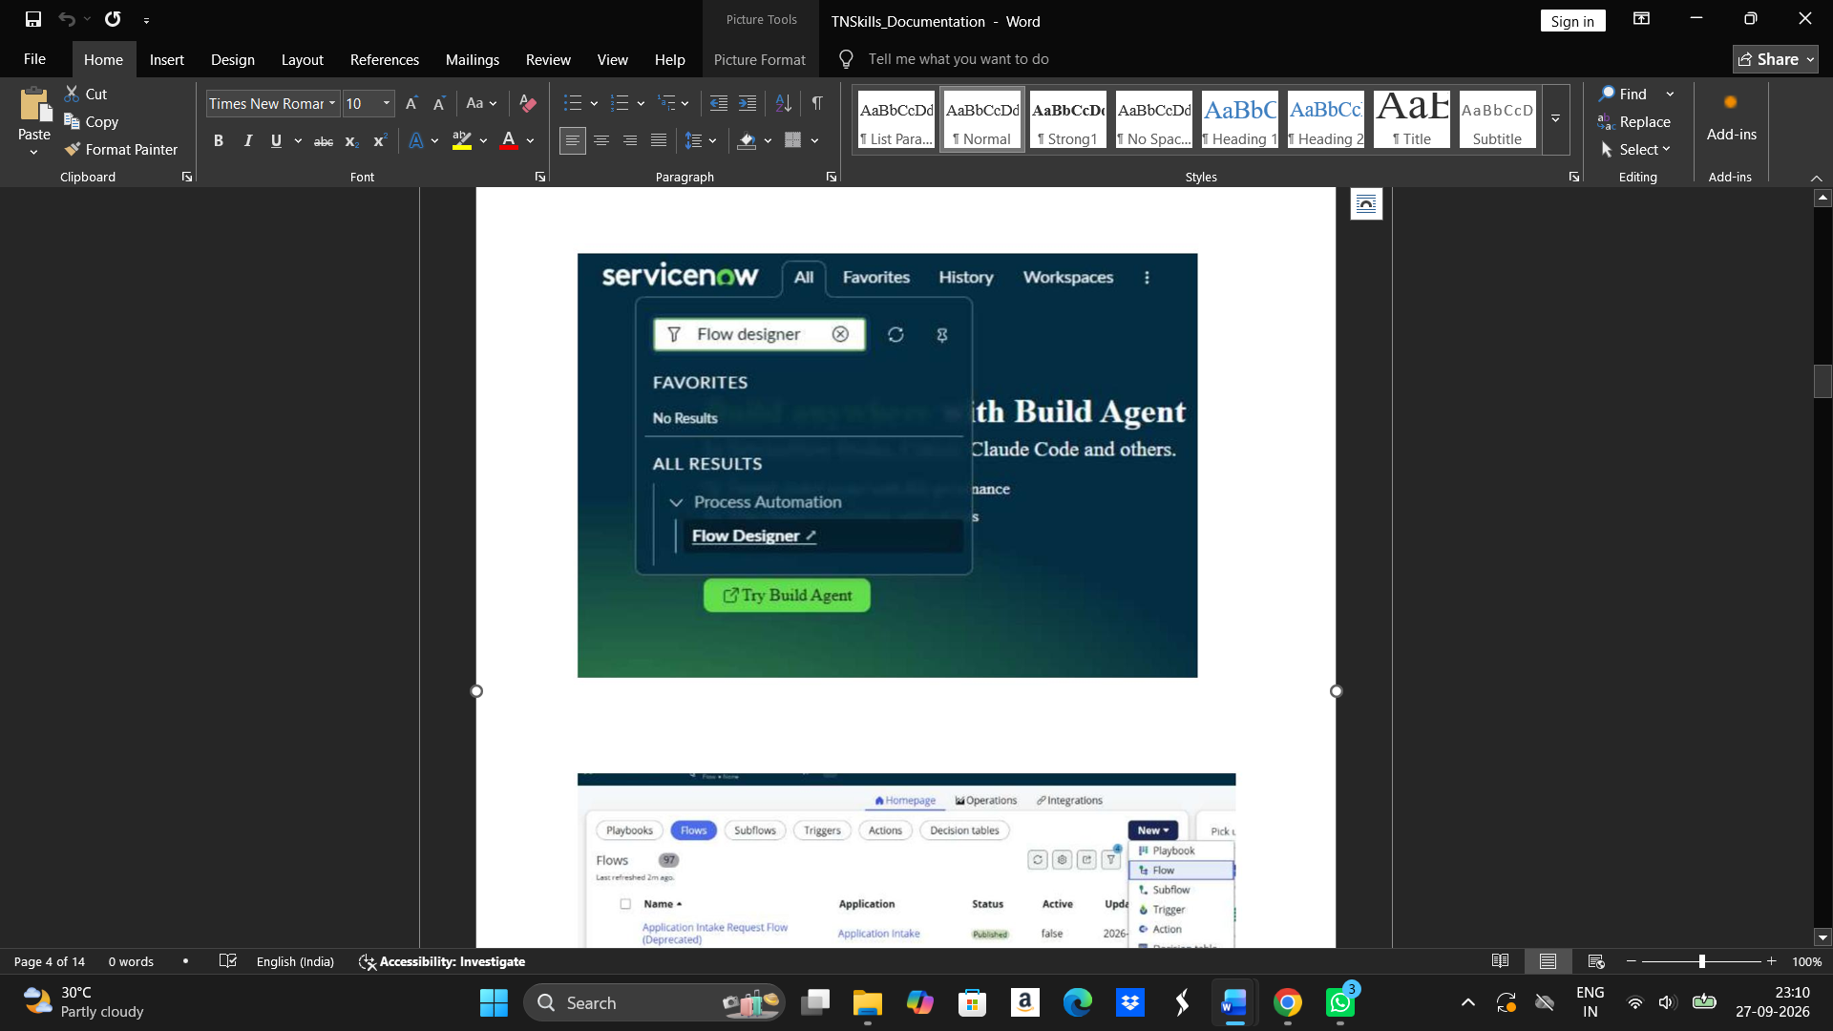

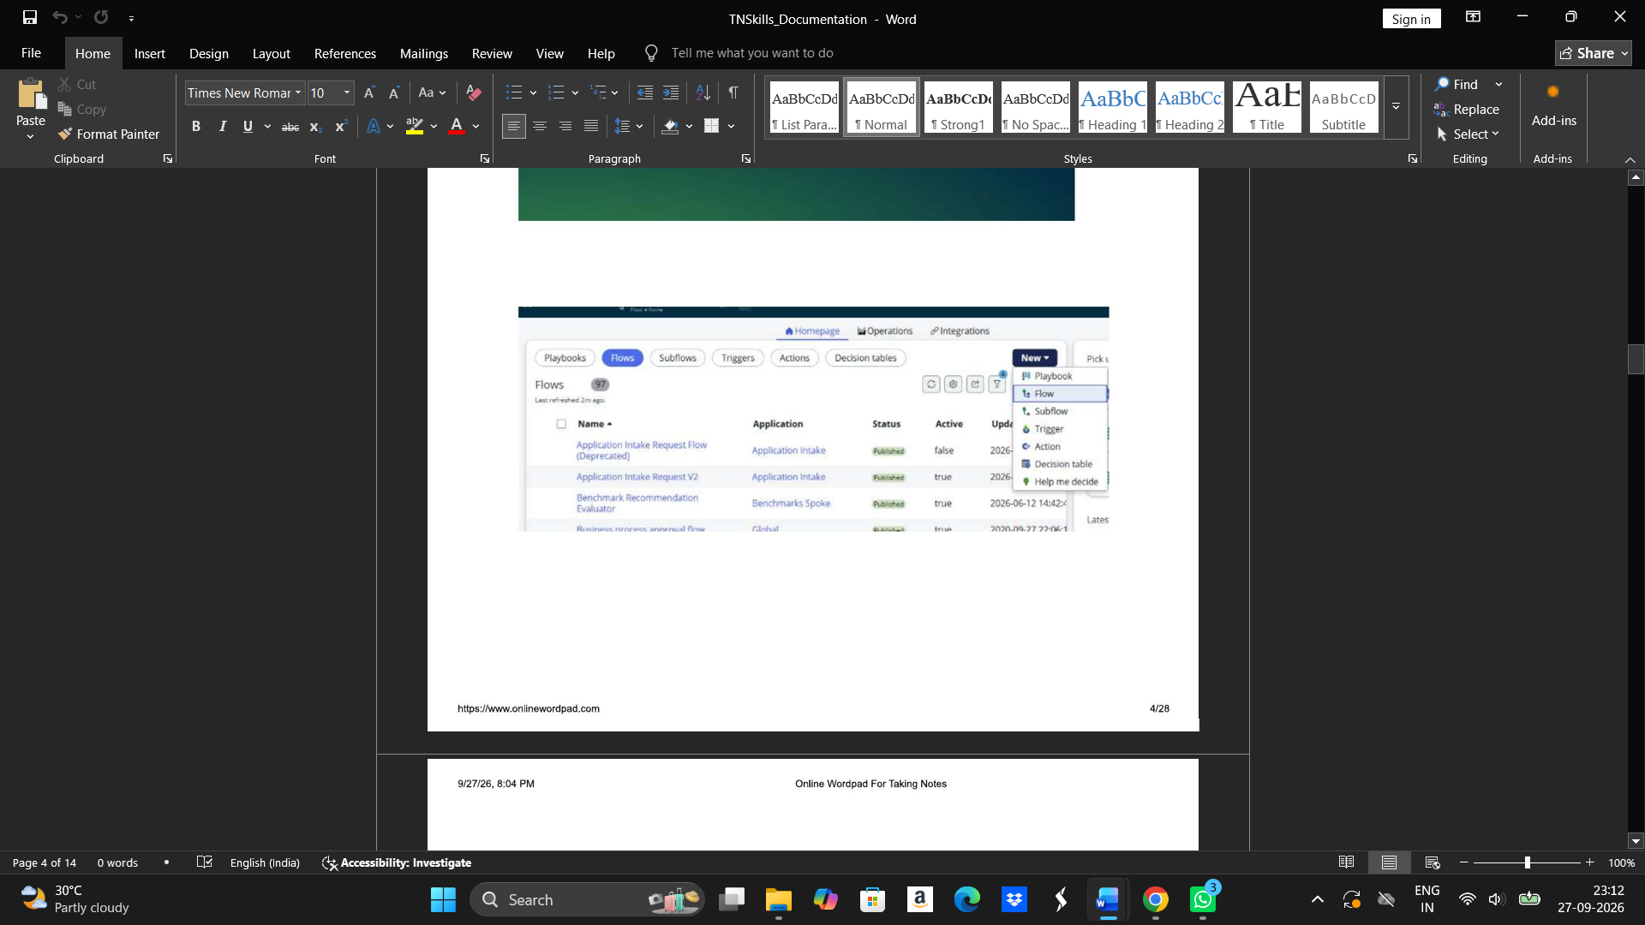

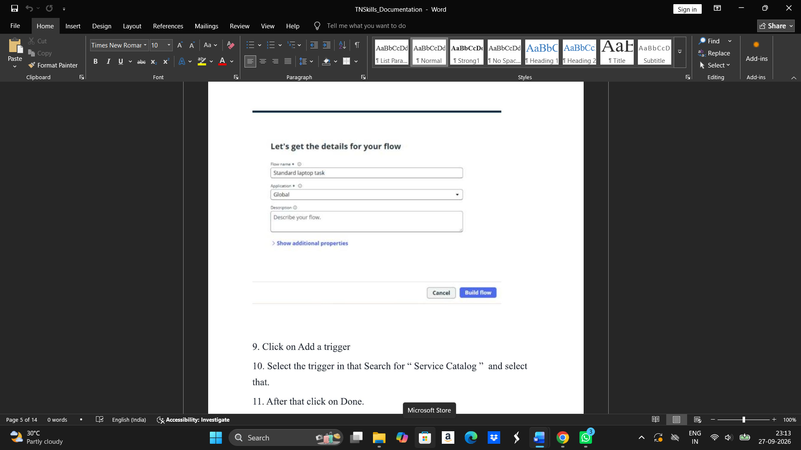
- Click on Add a trigger
- Select the trigger in that Search for “ Service Catalog ” and select that.
- After that click on Done.
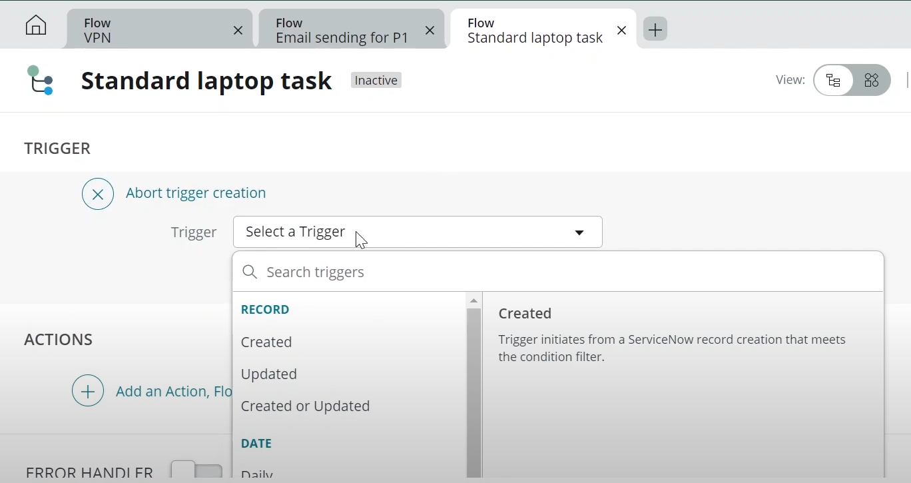

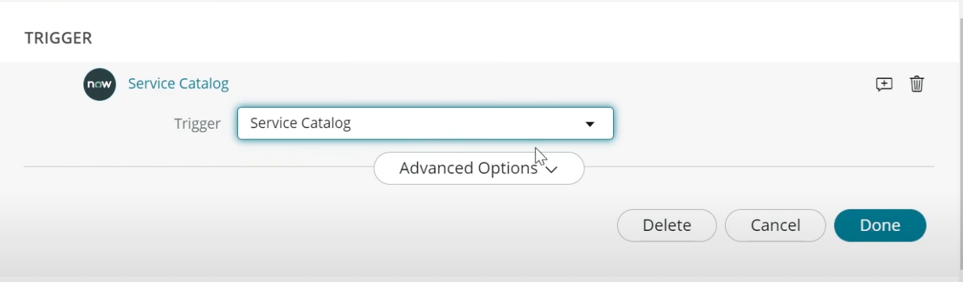
- Now under Actions.
- Click on Add an action.
- Select action in that search for “ Create Catalog Task ” and select that.
- Mention these in that action
- Action as Create Catalog Task
- Drag and drop the Requested Item Record in the Request item.
- Table will be auto populated as a Catalog Task.
- Mention the short description as “ Laptop need to Configured ”.
- Click on add field value
- Select description field and value as “ Laptop need to Configured ”.
- Select Assignment group field and value as “ Hardware ”.
- Select Approval field and value as “ Approved ”.
- Leave the remaining as default and click on Done.
- Click on save the Flow.
- And Click on Activate again click on Activate.

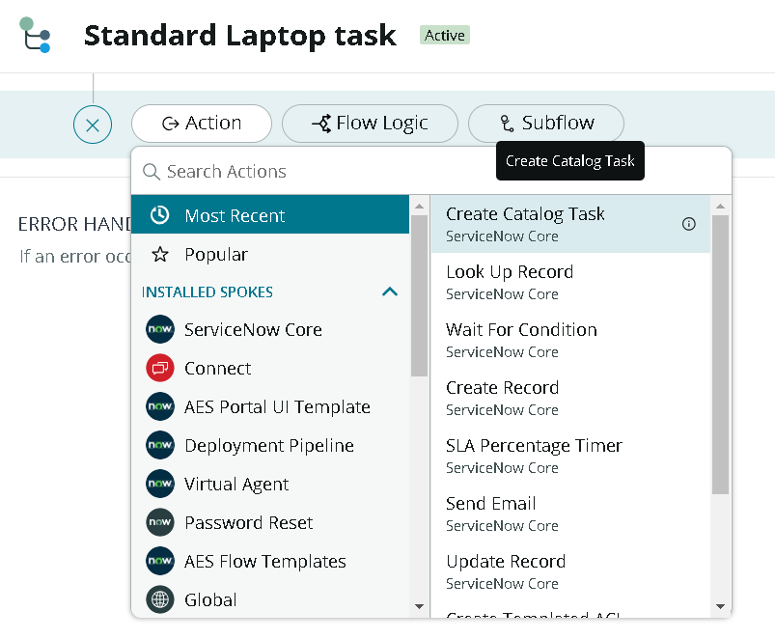
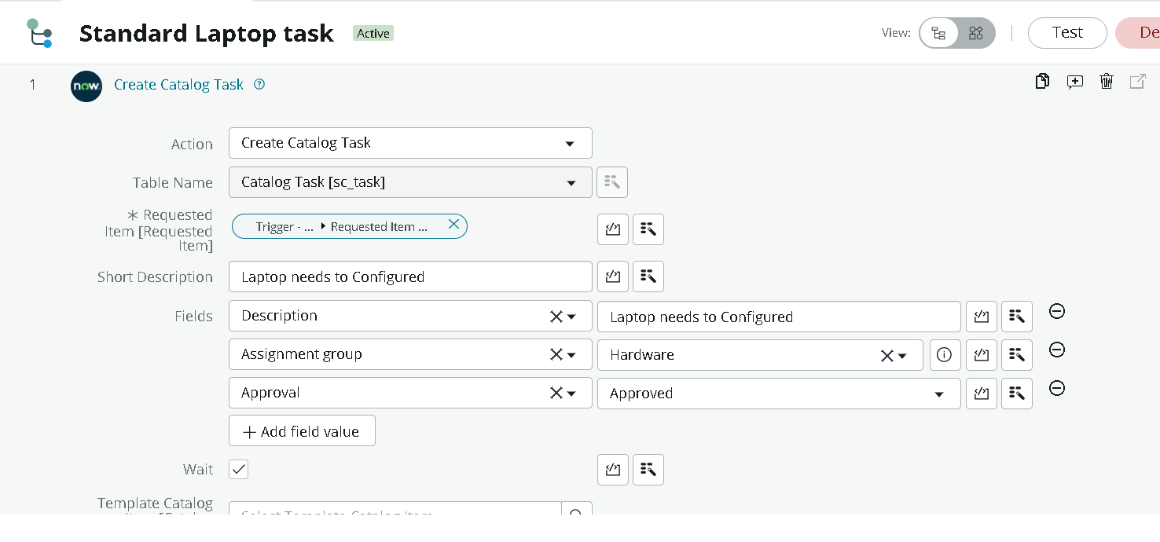

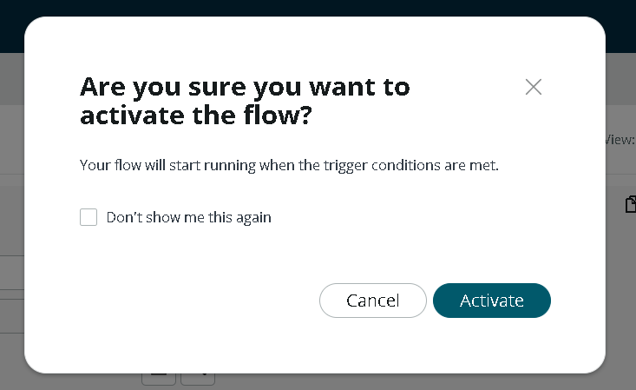

Milestone 2 : Flow assignment
Activity 1 : Flow Assignment to Standard laptop service Catalog.
- Open ServiceNow.
- Click on all search for Maintain Items.
- Select Maintain Items.
- Under the name field search for Standard Laptop Select that record.
- Under that record select Process engine
- Remove the remaining automations and add Flow.
- Add the flow that was created with the name “ Standard Laptop Task”.
- Click on the menu to save the record.

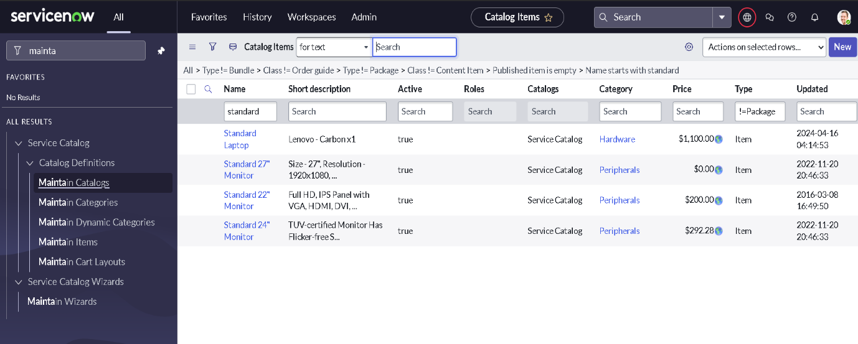

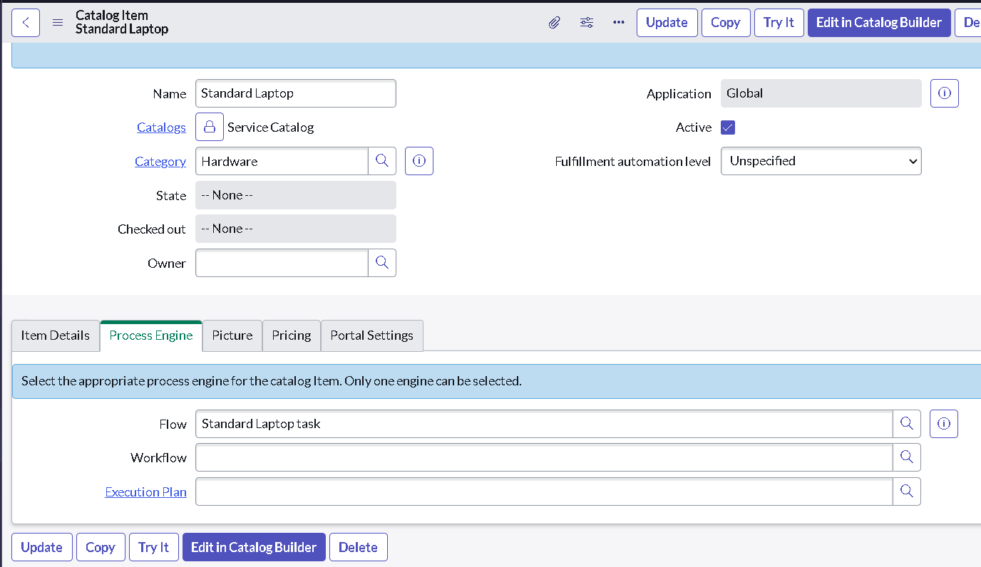

Milestone 3 : Service Catalog
Activity 1: Service Catalog for placing order and get Approval

- Click on All >> Search for “ Service Catalog ”.
- Click on Service Catalog >> click on Hardware.
- Scroll a bit to find the “ Standard Laptop ” click on that.
- After that click on “ Order Now ” to place the request.
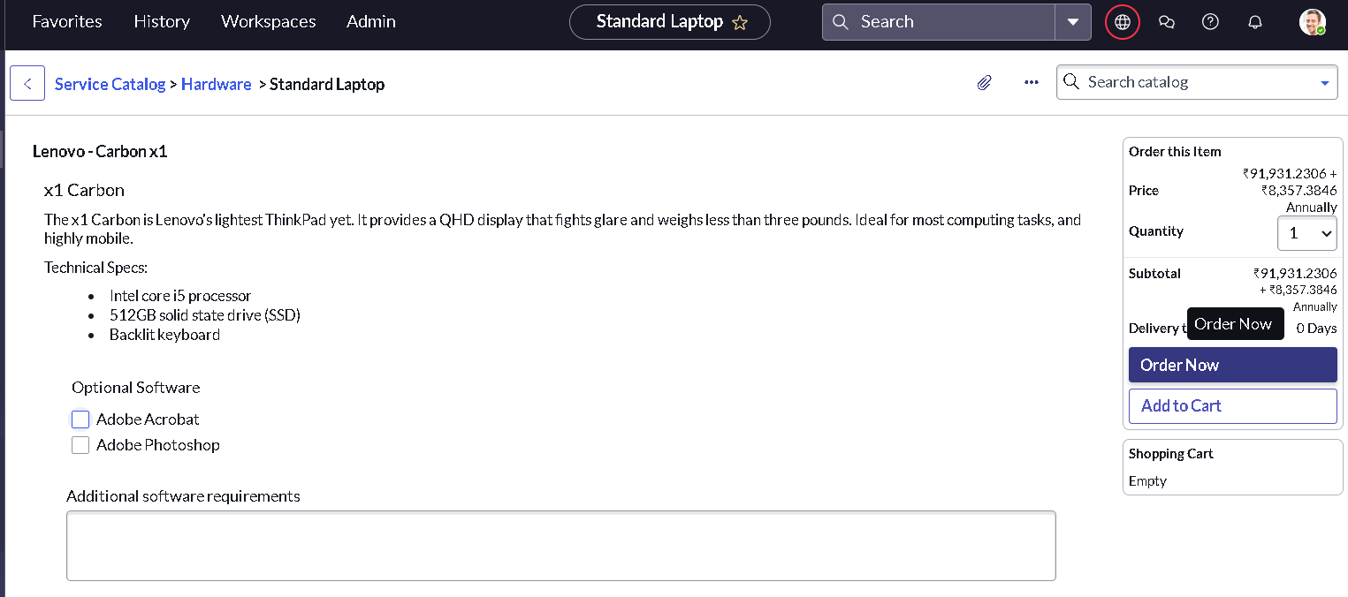
- Now we will see the Order status
- In that click on the Request Number
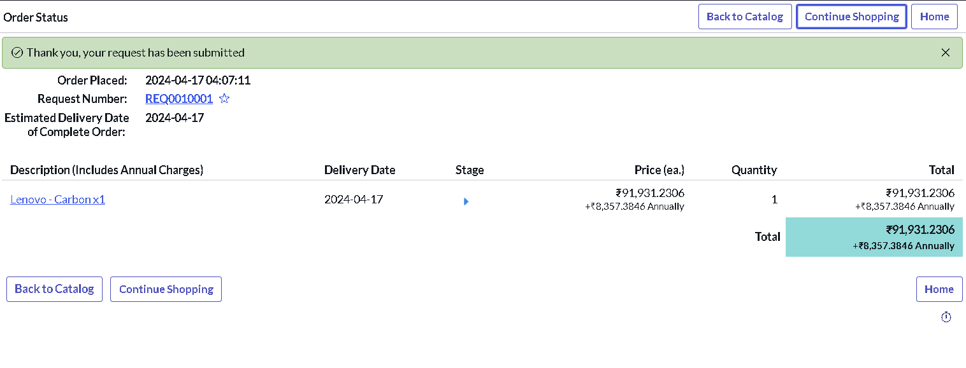

- It will open the Requested number record.
- Scroll down Click on the Approvers Section.
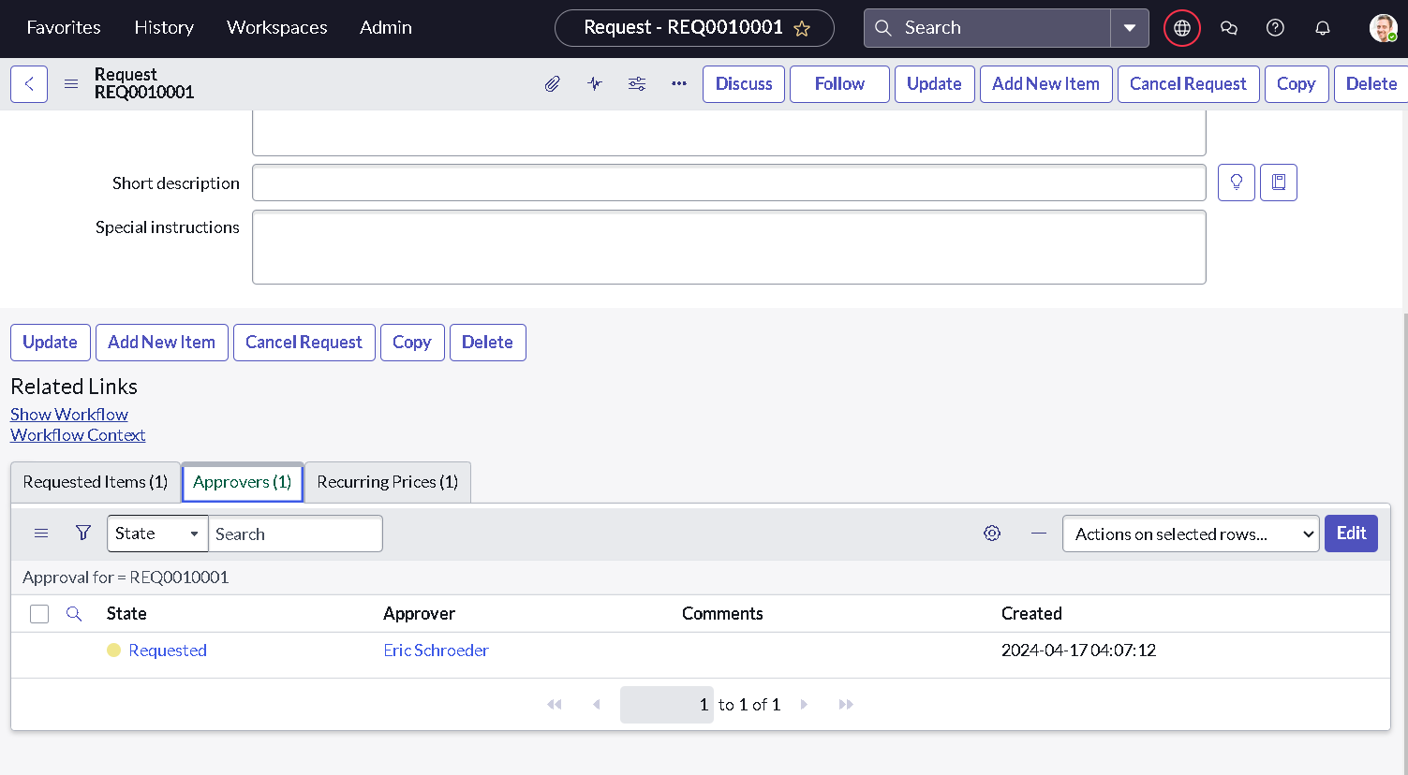

- Right Click on the Record to see config in that Click on the Approve.
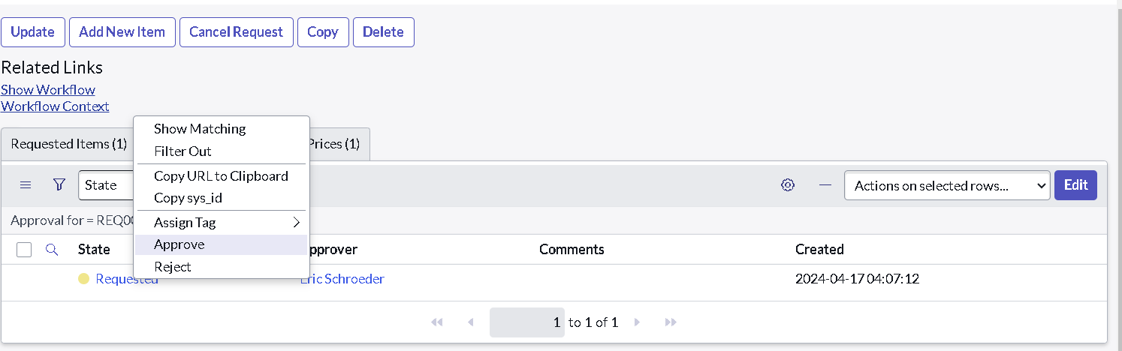
- Then click on the Requested item Section
- Open that Requested Item record

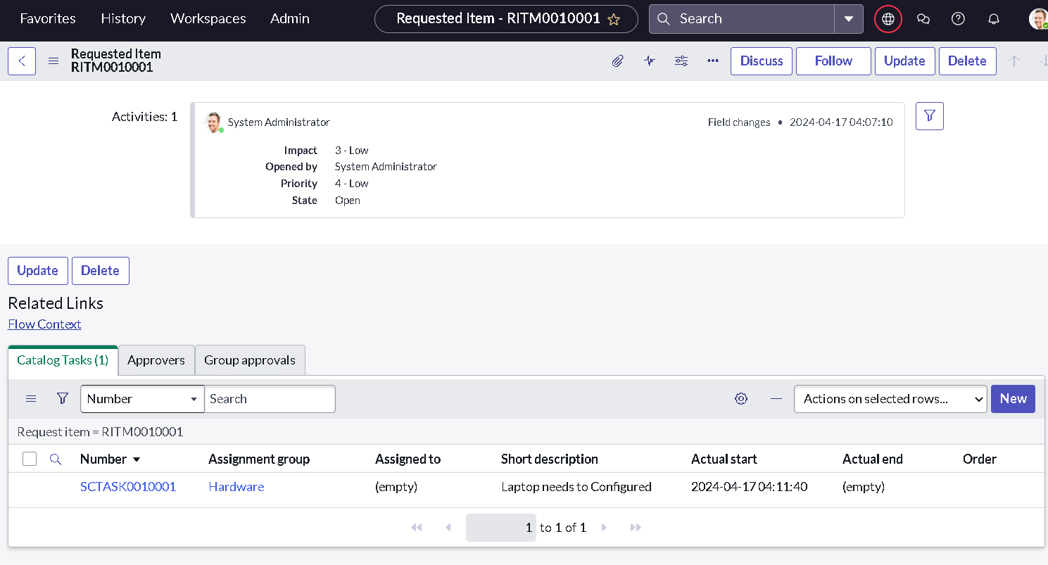
- Scroll down to the “ Catalog tasks ” Section
- Open the record to see the updated status of the record with Short description and Assigned group.

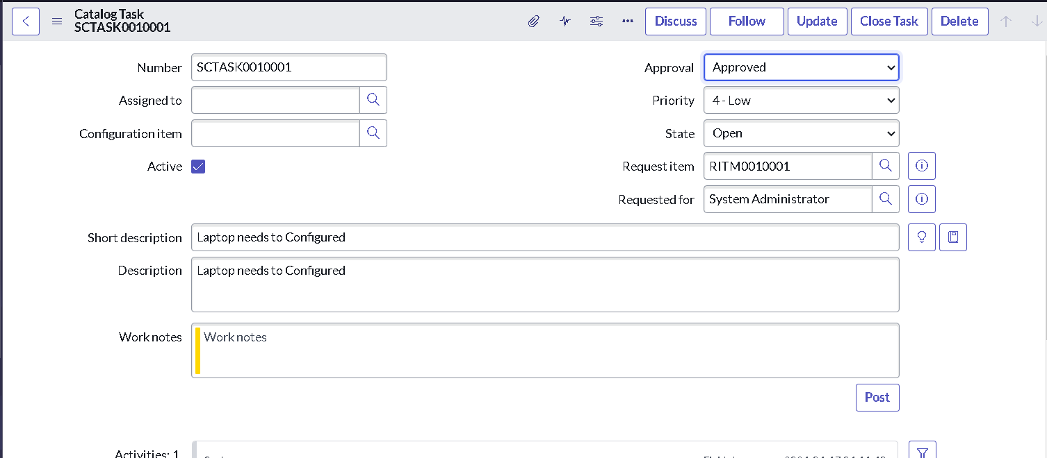

Demo Link:
https://drive.google.com/file/d/1a930QjzW1CPUTE6-aKdmTuEg_dIcc4Iq/view?usp=drivesdk

Conclusion :
By automating the standard laptop procurement process with ServiceNow's Flow Designer, the project effectively addresses inefficiencies and reduces manual overhead. This streamlined workflow ensures timely configuration of laptops, minimizes user wait times, and enhances overall productivity within the IT department. The implementation of this automated solution not only optimizes resource allocation but also significantly improves the user experience by providing a seamless and efficient procurement process.

